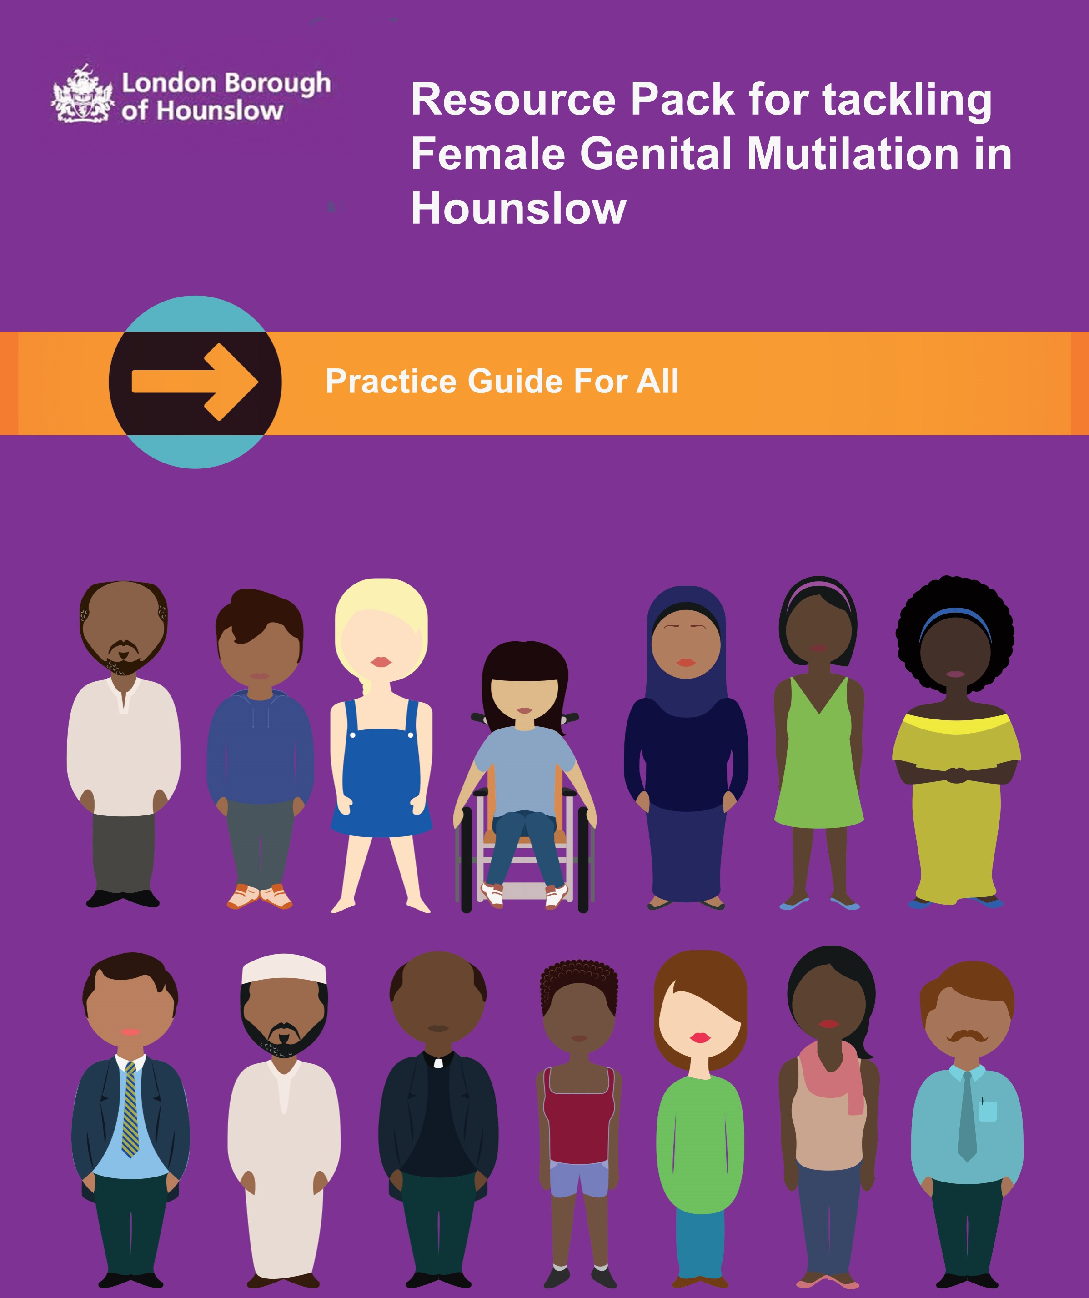
Hounslow Safeguarding Children Board
‘There are few professionals who are aware of the legislations and work which can happen to prevent FGM and most professionals do not understand the consequences of FGM on our young people’. [Local primary school in Hounslow teacher training, 2016]

The Hounslow Resource Pack began in 2016 when concerned professionals [teachers, statutory staff, health visitors and police] took an interest in what the Hounslow Safeguarding Children’s Board was doing to address FGM in our local community.

FORWARD was brought into this initiative to oversee and facilitate the awareness as well as share resources to professionals in order to facilitate the engagement of FGM affected communities in Hounslow. FORWARD worked in partnership with statutory staff, health visitors, West Middlesex Hospital, police and teachers across the borough.

FORWARD works primarily with women and girls from African communities to tackle the practice of FGM in the UK through community engagement, youth activism and advocacy.

This booklet shares lessons and experiences of Hounslow FGM programme, with the aim of providing insight into FGM and direct work resources, which all professionals can use to engage with children, young people and affected communities.

The terms “Female Genital Mutilation“refers to all procedures involving partial or total removal of the external female genitalia or other injury to the female genital organs for non-medical reasons.

Female Genital Mutilation procedures may be accompanied by a ceremony and seen as an important occasion. Families who practice Female Genital Mutilation do not think of it as abuse. Religious, social, cultural reasons are explanations and motives given by individuals and families who support the practice. Female Genital Mutilation is a traumatic ordeal and may have psychological effects, as there have been reports of post-traumatic stress, flashbacks, anxiety and panic attacks.

Female Genital mutilation is CHILD ABUSE.
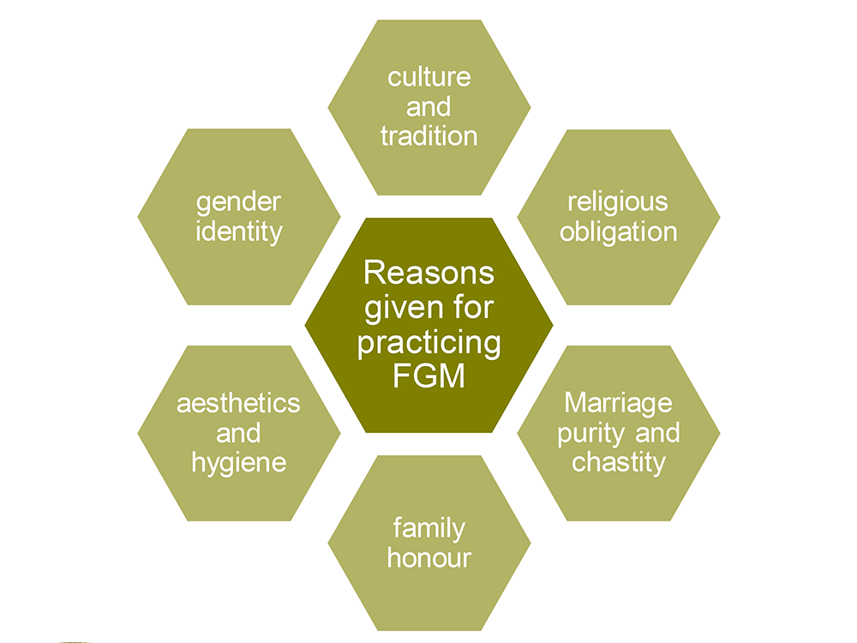

There are FOUR recognized classifications of female Genital Mutilation:
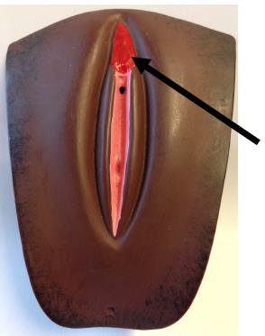

Type 1 Removal of the hood of the clitoris (sometimes called Sunnah)

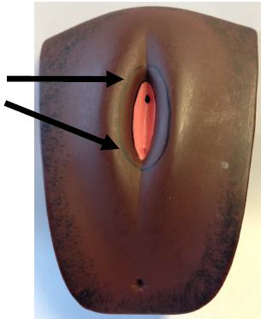

Type 2 Excision Removal of the clitoris with partial or total excision of the labia
Minora

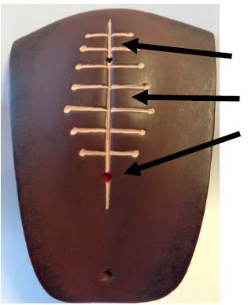

Type 3 Infibulation Removal of the clitoris and labia minora with narrowing by stitching of the vaginal opening

**Type 4 All other harmful procedures, such as: pricking, piercing, incision, scraping, cauterization and Labia pulling.

Female Genital Mutilation can be extremely dangerous and can cause physical harm, injury and sometimes death.

Girls and women who have had Female Genital Mutilation may have physical symptoms and emotional problems that continue throughout their adult lives.

Short Term Health Implications
- Shock
- Bleeding
- Organ Damage
- Urine retention

Long Term Health Implications
- Recurring kidney, urinary or virginal infection
- Infertility / Complications in pregnancy or childbirth / Menstrual problems
- Mental Heal problems such as anxiety, post-traumatic stress disordered
- Cysts and abscesses
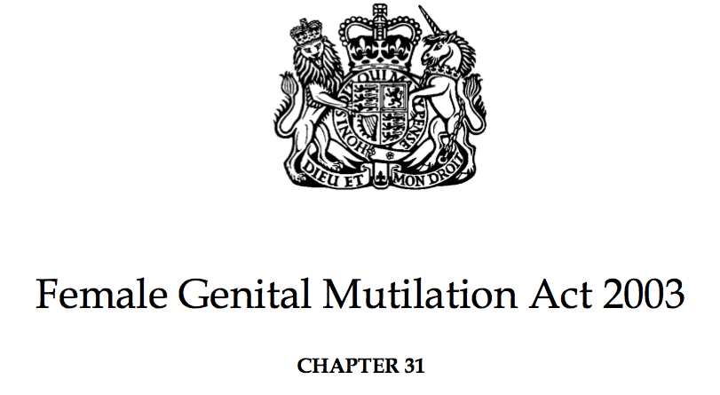

Under the Female Genital Mutilation Act 2003 and in the Serious Crime Act 2015 it makes clear that it is an offence in England, Wales and Northern Ireland for anyone (regardless of their nationality and residence status) to:
- Perform Female Genital Mutilation in the UK and abroad
- Assist the carrying out of Female Genital Mutilation in the UK or abroad
- Assist a girl to carry out Female Genital Mutilation on herself in the UK or abroad
- Assist from the UK and non-UK person to carry out Female Genital Mutilation outside the UK on a UK national or a permanent UK residence.

Any person found guilty of an offense under the Act of 2013 will be liable to a maximum penalty of 14 years imprisonment, or a fine, or both.

Mandatory Duty to report Female Genital Mutilation: -
Teachers along with health and social care professionals, are requires under a new mandatory duty in the Serious Crime Act (2015) to report any case of known Female Genital Mutilation disclosed by anyone under the age of 18year sold to the police.

Communities at Risk
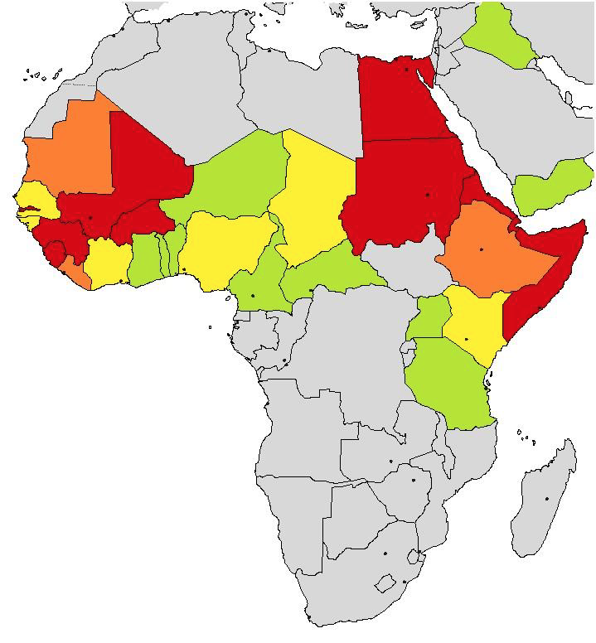
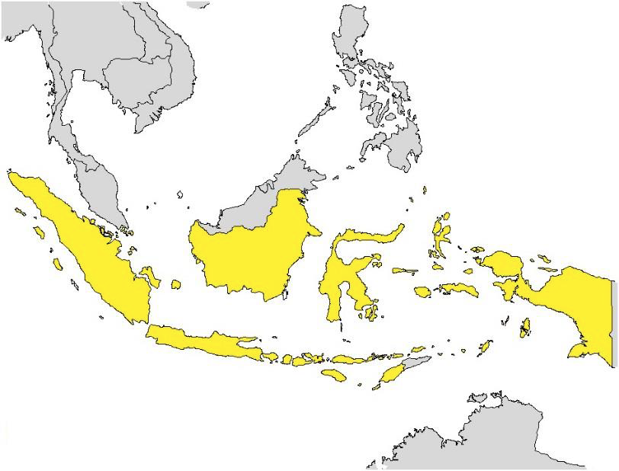
Africa
Asia
Middle East

UNICEF 2013 showing
countries where girls and
women aged 15 to 49 have undergone FGM

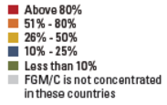

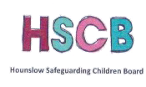
Hounslow FGM Pathway

Concerns for a female child from a high prevalence community

One of the following risks has been identified
•Child or friend has expressed concern of risk of FGM
•Discussion of "special procedure" or talk of a ceremony taking place (to make her a woman)
•Discussion of vaccinations and or absence from school
•Girl and or her family talking about a long holiday to a country of origin or to a where FGM is prevalent
•Knowledge of FGM already carried out in family
•Indicators procedure may have taken place

CFAN referral for intelligence gathering and risk assessment.

Not assessed as high risk. Action Plan as deemed necessary by
Children's Social Care and/ or Early Help Hounslow.

Outcome stored by Children's Social Care. Letter generated to GP, Health Visitor, School Nurse (and school if appropriate)

AT RISK
Section 47 Children Act 1989
In the case of a child at risk of immediate significant harm or removal from the country to allow that significant harm to take place; contact must be made immediately with the Police - by calling 999

Risk assessments that can be used for different aged children to help professionals to assess whether a child is at risk of FGM.

RISK1: PREGNANT WOMEN (OR HAS RECENTLY GIVEN BIRTH)
This is to help you make a decision as to whether the unborn child (or other female children in the family) are at risk of FGM or whether the woman herself is at risk of further harm in relation to her FGM.

Indicator | Yes | No | Details
Woman comes from a community known to practice FGM
Woman has undergone FGM herself

Husband/ partner comes from a community known to practice FGM

A female family elder is involved / will be involved in care of children/ unborn child or is influential in the family

Woman/ family has limited integrated in the UK community

Woman and or husband/ partner have limited/ no understand of harm of FGM or UK Law

Woman’s nieces, siblings and / or in-laws have undergone FGM

Woman has failed to attend follow up appointments with an FGM clinic/ FGM related appointments

Woman is reluctant to undergo genital examination

SIGNIFICANT OR IMMEDIATE RISK
Woman already has a daughter who have undergone FGM

Woman or woman’s partner / family requested reinfibulation following childbirth
Woman is considered to be a vulnerable adult and therefore issues of mental capacity and consent should be considered if she is found to have FGM
Woman says that FGM is integral to cultural or religious identity
Family are already known to social care services – if known, and you have identified FGM within a family, you must share this information with social services.
Please remember: any child under 18 who undergone FGM must be referred to police under the Mandatory Reporting duty using the 101 non-emergency number.

RISK2: CHILD/ YOUNG PERSON (under 18 years old)
This is to help when considering whether a child is AT RISK of FGM, or whether there are other children in the family for whom a risk assessment may be required

Indicator | Yes | No | Details
Child’s mother has undergone FGM
Other female family members have had FGM

Father comes from a community known to practice FGM

A female family elder is very influential within the family and is/will be involved in the care of the girl

Mother/family have limited contact with people outside of her family

Parents have poor access to information about FGM and do not know about the harmful effects of FGM or UK law

Parents say that they or a relative will be taking the girl abroad for a prolonged period – this may not only be to a country with high prevalence, but this would more likely lead to a concern

Girl has spoken about a long holiday to her country of origin/another country where the practice is prevalent

Girls presents symptoms that could be related to FGM

Family not engaging with professionals (health, school, or other)

Any other safeguarding alert already associated with the family

SIGNIFICANT OR IMMEDIATE RISK
A child or sibling asks for help
A parent or family member expresses concern that FGM may be carried out on the child
Girl has confided in another that she is to have a ‘special procedure’ or to attend a ‘special occasion’. Girl has talked about going away ‘to become a woman’ or ‘to become like my mum and sister’

Girl has a sister or other female child relative who has already undergone FGM

Family/child are already known to social services – if known, and you have identified FGM within a family, you must share this information with social services

Please remember: any child under 18 who undergone FGM must be referred to police under the Mandatory Reporting duty using the 101 non-emergency number.

RISK3: CHILD/ YOUNG PERSON (under 18 years old)
This is to help when considering whether a child HAS HAD FGM

Indicator | Yes | No | Details
Girl is reluctant to undergo any medical examination
Girl has difficulty walking, sitting or standing or looks uncomfortable

Girl finds it hard to sit still for long periods of time, which was not a problem previously

Girl presents to GP or A&E with frequent urine, menstrual or stomach problems

Increased emotional and psychological needs e.g. withdrawal, depression,
or significant change in behaviour

Girl avoiding physical exercise or requiring to be excused from PE lessons without a GP’s letter

Girl has spoken about having been on a long holiday to her country of origin/ another country where the practice is prevalent

Girl spends a long time in the bathroom/toilet/long periods of time away from the classroom

Girl talks about pain or discomfort between her legs

SIGNIFICANT OR IMMEDIATE RISK
Girl asks for help
Girl confides in a professional that FGM has taken place
Mother/family member discloses that female child has had FGM

Family/child are already known to social services – if known, and you have identified FGM within a family, you must share this information with social services

Please remember: any child under 18 who undergone FGM must be referred to police under the Mandatory Reporting duty using the 101 non-emergency number.

These are examples of lesson plans / activities that can help professionals when discussing FGM with different aged children. Before completing these activities in a classroom forum, please provide a warning that it may be upsetting and if any child(s) needs to take a break or speak to a teacher afterwards, they can do this.

ACTIVITIES FOR PRIMARY SCHOOL AGED CHILDREN

ACTIVITY 1: Human Rights

Learning Outcome | Resources
- Know how to protect themselves and others  - Know who to go to in order to get support  - Feel confidence to discuss FGM with professionals | - Video  - Human Right picture Book [We are all born free]  - Colouring pen  - Coloured paper

Starter/ introduction
length of lesson – 45 mins
Set up a safe environment.

Introduce the session by explaining that you will be showing a video about a child who says ‘My Body My Rules’.
From YouTube show My Body My Rules (3.31min)
https://www.youtube.com/watch?v=W2IStB6Z3Vw

Pull together a coloured paper and ask the following questions:
- What might be going on for the girl?
- What feelings will the little girl be having?
- Who do you think she should talk to if she feels unsafe?
- Put yourself in this situation, what would you do or advice the little girl to do when she feels unsafe?

Talk about Children’s Right, use the book ‘we are all born free’ to support this, include that FGM is against the Law.

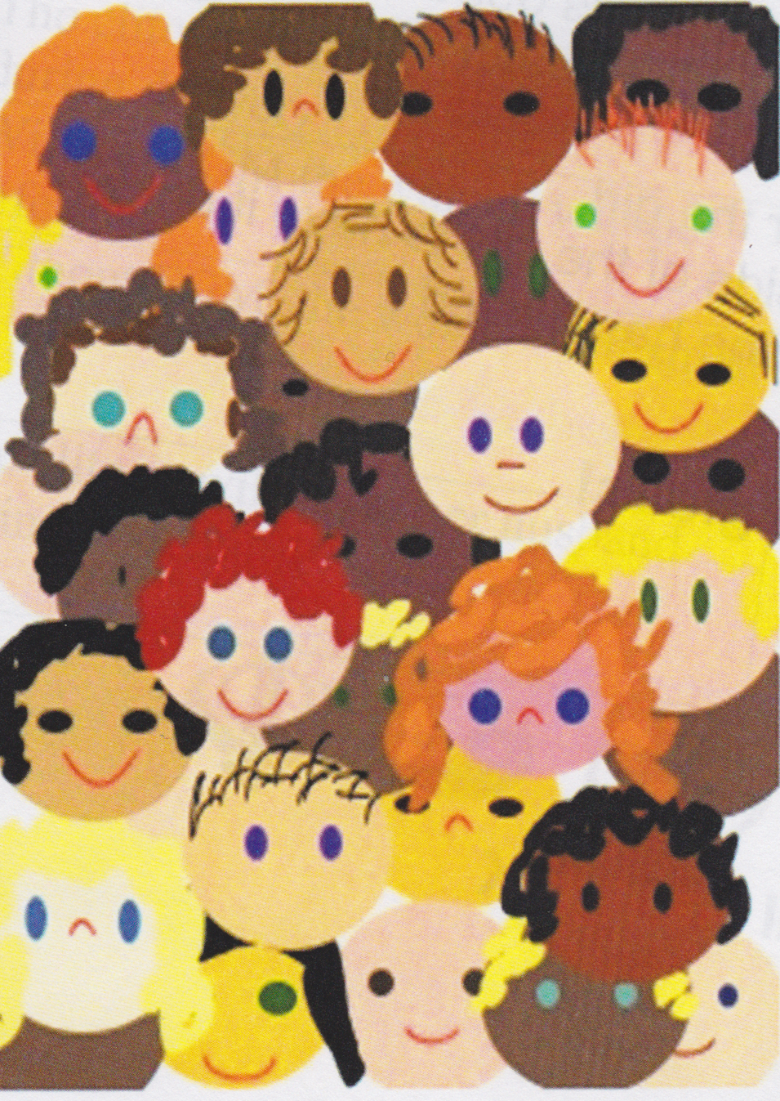
HUMAN RIGHTS

ACTIVITY 2: All About Body Parts

Learning Outcome | Resources
- Know how to protect themselves and others  - Know who to go to in order to get support  - Feel confidence to discuss FGM with professionals | - Different coloured post-it notes  - Colouring pen  - Large A3 paper  - Laminated cards

Starter/ introduction
length of lesson – 45 mins
Set up a safe environment.

Introduce the session by explaining that you will be labeling the different body parts.

Pull together a large (A3) paper and create a large representative of the human body so that the child can help label key body parts. Once this is completed get the child to identify which body parts are PRIVATE.

Use this activity to lead on to discussing the appropriate language we may use to describe parts of our body [Curriculum guidance says age pupil aged 5-7 should know the terms penis and vagina].

Introduce this vocabulary in measuring terms when explaining that pants region should not be touched. Say that there are special circumstances when touching is OK and be clear when this is.

Link this to FGM, explain the following:
- FGM is when people change, alert or remove parts of the girls genitals
- Adults do this because they believe it is OK for the girls
- It is harmful to the girl’s health
- It can be scary
- Sometimes she is taken to the UK to have it done, and then comes back when she is healed.

Please refer to earlier sections explaining FGM and Legislations.

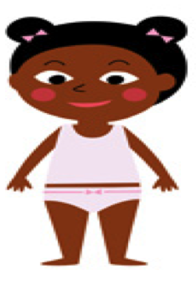
MY BODY,
MY RULES…

ACTIVITY 3: Keeping Safe

Learning Outcome | Resources
- Know how to protect themselves and others  - Know who to go to in order to get support  - Feel confidence to discuss FGM with professionals | - Different coloured post-it notes  - Colouring pen  - Large A3 paper  - Laminated cards

Starter/ introduction

Set up a safe environment.

Introduce the session by explaining that you will be talking about the importance of keeping safe. Ask the child what makes them feel safe and what makes them feel unsafe?

Introduce the word SECRET: Explain to the child the following: -

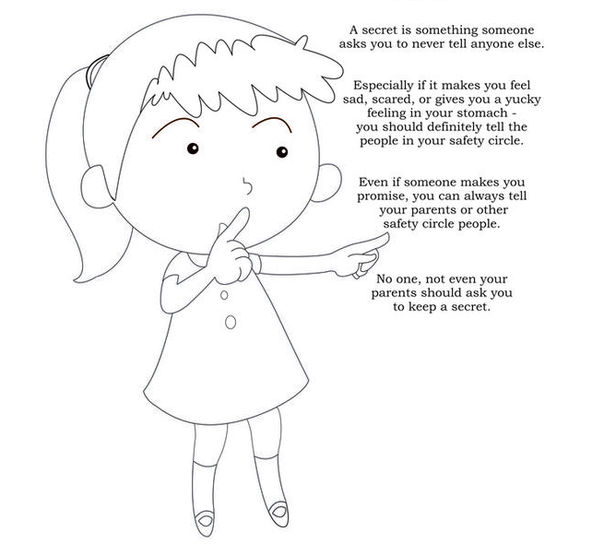
Link this to FGM as something that is sometimes referred to as being a secret, explain the following:
- FGM is when people change, alter or remove parts of the girls genitals
- Adults do this because they believe it is OK for the girls
- It is harmful to the girl’s health
- It can be scary
- Sometimes she is taken out of the UK to have it done, and then comes back when she is healed.

Please refer to earlier sections explaining FGM and Legislations.

ACTIVITIES FOR SECONDARY SCHOOL AGED CHILDREN
ACTIVITY 1: Think Again Video- MYTH/ FACT

Learning Outcome | Resources
- Know how to protect themselves and others  - Know who to go to in order to get support  - Feel confidence to discuss FGM with professionals | - Video  - A3 paper  - Laminated cards

Starter/ introduction

Set up a safe environment, by given child(s) the opportunity to speak to staff afterwards, if they are upset they can leave at any time and for ground rules to be agreed before the start of the session.

Introduce the session by explaining that you will be showing a video about a young girl in this country who knows that her family want her to back to their country of origin to be circumcised.
From YouTube show Think Again: The Film (6.45min)
https://www.youtube.com/watch?v=kzBNTtR7toE

Ask the young person to pick out any arguments for or against FGM as they watch they watch the movie. Share the work.

Talk about the ‘Myths and Facts’ about FGM, using laminated cards.

IF YOU DON’T HAVE FGM YOU WILL SMELL

Answer: this is a Myth. The body is designed to ensure that a woman can pass urine, menstruate, have intercourse and deliver baby. If the opening is narrowed or closed there is a high risk of infection, as the body cannot get rid of urine and blood effectively. This can cause an infection, which can also cause the girl to smell.

SUNNA IS NOT A TYPE OF FGM

Answer: this is a Myth. Sunna is a word that is used in the Qur’an to mean something sacred. This has been adopted by FGM practicing communities to describe type 1 FGM. FGM is not a religious practice but people often think it is because this word is used.

IF YOU DON’T HAVE FGM YOU WILL THINK ABOUT SEX ALL THE TIME AND WANT TO HAVE SEX WITH MANY MEN

Answer: this is a Myth. Women who have not had FGM do not think about or want sex all the time. The difference is that a woman who has had FGM often feels pain during intercourse so does not enjoy it. This can mean that even women who are married can find sex very painful and this can cause problems in their relationship.

IF YOUR FAMILY WANT YOU TO HAVE FGM, YOU DON’T HAVE A CHOICE

Answer: this is a Myth. FGM is against the law and anyone who makes you have it done could be arrested and may end up going to prison for 14 years, it is your body and nobody should hurt or damage it in any way.

HAVING FGM IS A MATTER OF PERSONAL CHOICE

Answer: this is a Myth. FGM is against the law for children and women in this country and even if you choose to have it done you will be breaking the law and the person arranging the cutting or carrying the cutting could go to prison. This is because women or girls may be persuaded to have FGM or feel they have no choice.

FGM IS AGAINST THE LAW IN THIS COUNTY AND PUNISHABLE WITH A PRISON SENTENCE

Answer: this is a fact. It is against the law for a British National to have FGM in the UK or abroad and anyone caught arranging or performing it risks going to prison for up to 14years.

IT IS OK TO GO TO ANOTHER COUNTRY TO HAVE FGM DONE

Answer: this is a Myth. It is against the law for a British National to have FGM in the UK or abroad.

EVERY WOMAN IN THE WORLD HAS THE RIGHT NOT TO HAVE FGM

Answer: this is a fact. The UN Convention of the rights fresh child article 19 states that everyone has a right to be protected from being hurt or mistreated’.

PEOPLE FROM OTHER COMMUNITIES SHOULD NOT GET INVOLVED. FGM IS NOTHING TO DO WITH THEM AND THEY DON’T UNDERSTAND

Answer: this is a Myth. Many different people including teachers, health professionals and the police are working to stop FGM as it can cause long term health problems, pain and distress for those who have had it done. Members of the FGM practicing communities are working in partnership wit professionals to stop the practice.

ACTIVITY 2: Think Again

Learning Outcome | Resources
- Know how to protect themselves and others  - Know who to go to in order to get support  - Feel confidence to discuss FGM with professionals | - A3 paper  - Coloured pens

Starter/ introduction

Set up a safe environment.

This is designed to run after the young person had watched the ‘Think Again’ video.

Explain to the young person that in the Think Again, the young person said that she was ‘scared’, and that she ‘didn’t have a choice’: Think about the following:

- What would you say?
- What could you do?
- What do you think she might say to her family?
- Make a list of what her options are and what the consequences might be?

ACTIVITY 3: Problem Letter

Learning Outcome | Resources
- Know how to protect themselves and others  - Know who to go to in order to get support  - Feel confidence to discuss FGM with professionals | - A3 paper  - Coloured pens

Starter/ introduction

Set up a safe environment.

Ask the young person to image how they would respond to the following letter sent to a problem page:

‘I am a 14 year old girl. I have two sisters [age 4 and 9, and one brother, aged 7]. My parents have recently started talking about taking me and my brother and sisters back ‘home’ for the summer holidays and have said that there will be a special party for the girls. My sisters are really excited about this and my brother is annoyed that he is being left out. I am really worried and am not excited. I have heard that sometimes these parties are where you get FGM done to you. I don’t want to have this done to me, or my sisters, but I don’t want to go against my parents. But I am also worried that if I don’t have FGM then I will never be able to get married or that people will think I just want sex all the time. What should I do?’
Name and address withheld.

Country | Term used for FGM | Language
Chad – Sara subgroup | Bagne  Gadja
Egypt | Thara  Khitan  Khifad | Arabic  Arabic  Arabic
Ethiopia | Megrez  Absum | Amharic  Harrir
Eritrea | Mekhnishab | Tigregna
Gambia | Niaka  Kuyango  Musolula Karoola | Mandinka  Mandinka  Mandinka
Kenya | Kutairi  Kutairi was ichana | Swahili  Swahili
Nigeria | Ibi/ Ugwu  Sunna | Igbo  Mandingo
Sierra Leone | Sunna  Bondo/ Sonde  Bondo  Bondo  Bondo | Soussou  Temenee  Mende  Mandingo  Limba
Somalia | Gudiniin  Halalays  Qodiin | Somali  Somali  Somali
Sudan | Khifad  Tahoor | Arabic  Arabic

Police
If you think that the situation involved immediate risk, then call the police on 999, or if you wish to report a concern call 101.

Project Azure
Project Azure is the Police Child Abuse Investigation Command’s response to FGM. They can be contacted on: 020 7161 2888

ChildLine
Children and young people can contact ChildLine about any problem, big or small, whether they are feeling worried, scared, stressed or just want to talk to someone, they offer information and support. www.childline.org.uk
Free 24hour helpline which does not show up on your bill: 0800 1111

Rights of women
National charity working to attain justice and equality by informing, education and empowering women about their legal rights. www.rightsofwomen.org.uk
Legal advice line: 020 7251 6577
Sexual Violence Legal Advice Line: 020 7251 8887

FORWARD
FORWARD is a charitable organization that works to prevent and support survivors of FGM. They provide both medical and physiological interventions.
E-mail: forward@forwarduk.org.uk
Tel: 0208 960 4000
Web: www.forwarduk.org.uk

Useful Web Resources
• http://www.londonscb.gov.uk/fgm_resources/
• www.fco.gov.uk/fgm
• www.forwarduk.org.uk
• www.rcog.org.uk
• www.rcm.org.uk
• www.nspcc.org.uk
• www.fgmelearning.co.uk
• www.gov.uk/government/publications/femalegenital-mutilation-resource-pack
• http://www.bbc.co.uk/news/av/magazine-39456400/labia-stretching-why-some-british-girls-are-told-to-do-it
•https://www.egfl.org.uk/sites/default/files/Services_for_children/Relationship_and_sex_education/St%20Werburgh%20FGM%20lesson%20plan%20%282%29.pdf​

