For help and support on CSE contact:
- For immediate attention call the police on 999

- If you have information that may help the Police, contact your local police on 101 or Crimestoppers on 0800 555 111.
Hounslow Children’s Services
- 020 8583 6600 (Option 1) (Monday - Thursday 9.00am – 5.00pm and Friday 9.00am – 4.45pm)
- 020 8583 2222 (out of hours and weekends)
- Visit www.houslow.gov.uk/cse

- Child Exploitation and Online Protection (CEOP) – www ceop.police.uk

- Childline – 0800 111 or visit www.childline.org.uk/Pages/Home.aspx for help and advice.

- PACE – provides parents with direct support and gives opportunities to speak or meet with other parents www.paceuk.info

- Parents Project – online resource Parents sharing advice to other parents on what they can do to manage behaviours and what they wish they had known. www.parentproject.com

- NSPCC can be contacted 24/7 for help and advice on 0808 800 5000 or visit https://www.nspcc.org.uk/
If you know someone in immediate danger call 999 and talk to the police.

Child Sexual Exploitation
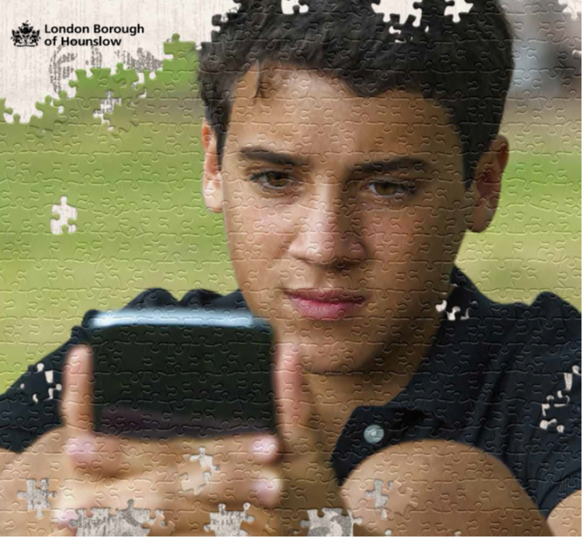

WARNING SIGNS FOR PARENTS, CARERS AND PROFESSIONALS

What is Child Sexual Exploitation?
Child Sexual Exploitation is a form of child sexual abuse. It is when someone uses a child (anyone under 18 years) by giving them money, gifts, food, alcohol, accommodation, power and/or status in exchange for them engaging in sexual activities. Children or young people may be tricked into believing they're in a loving, consensual relationship. They might be invited to parties and given drugs and alcohol. People who do this want young people to think they are a friend, or a boyfriend or girlfriend.
- Child Sexual Exploitation (CSE) happens to boys and girls.
- Child Sexual Exploitation can be really hard to spot.
- It happens to children from all communities.
- It happens to children of any age, especially in the 11-18 age range. But can also happen to younger children.
- Child Sexual Exploitation can happen to vulnerable adults too.
The child is vulnerable. They may be asked to do something that makes them feel uncomfortable. It is not their fault. This is sexual exploitation and it is a crime.
A Young Person you know might be;
- Going missing for short periods of time or even days
- Having expensive things bought for them that are unexplained
- Staying out late and whereabouts being unknown.
- Distancing themselves from family and friends
- Changing behaviour like becoming withdrawn or aggressive
- Sexualised behaviour such as touching people inappropriately
- Being picked up by people you don’t know
- A change in their performance at school or college
Starting or increasing alcohol or drug use
HOW DOES IT HAPPEN?
Young People can be ‘Groomed’ by someone who befriends them and makes them feel special.

A friend or group of friends could exploit them.

They could force the young person into dangerous situations
They can also try and isolate the young person from their friends, family and other people who care about them.
They could be exploited by someone they have met online.

WHAT CAN I DO TO PROTECT YOUNG PEOPLE?
- Stay alert to changes in behaviours or any physical signs of abuse
- Be aware of new, unexplained gifts or money.
- Make sure you understand the risks associated with young people online and putting measures in place to minimise these risks.
- Ensure you know who to contact if you have concerns. Do not ignore the signs.
- Make sure children are aware of risks online and only talk to people they know.
- Think of ways that you might be able to help young people to share information if they are worried about their own or another young person’s situation.
YOU NEED TO BE AWARE OF THE WARNING SIGNS SO YOU CAN EDUCATE YOUNG PEOPLE.

